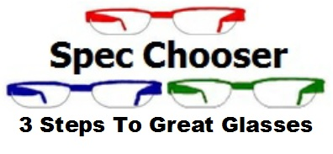

**Type of Prescription:**

* Distance
* Intermediate
* Reading

**Type of Lens:**

* Distance
* Intermediate
* Reading
* Bifocal
* Varifocal
* Office
* Sport
* Industrial

**How Much Thinning?**

* 1.5 lens
* 1.6 lens
* 1.67 lens
* 1.74 lens
* Glass lenses

**Finishes:**

* Reflection free
* Scratch resistance
* Blue Violet Protection
* Anti static
* Hydrophobic
* Photochromic

**Frame Shape:**

* Round
* Oval
* Square
* Rectangular

**Frame Material:**

* Metal
* Plastic
* Other

**Frame Style:**

* Full rim
* Semi Rimless
* Rimless